Our early work plan has a linear progression that breaks down the entire project into several parts. Then assigned to each group member. We hope that every part of the project will be completed smoothly

Our first part has been completed. At the beginning of the project, we have made a clear division of work for the entire work plan, and we have made specific requirements for the date of completion of the work, so as to ensure the completion of the project. Below we use the Gantt chart to show the work plan of project one. 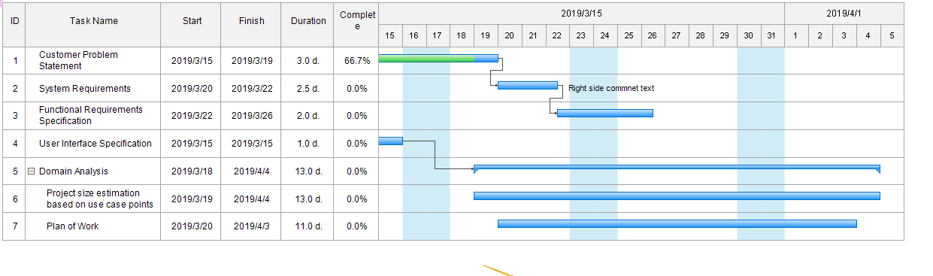At the same time, we also made a plan Gantt chart of the whole project to ensure that we have a clear understanding of the whole project. We will clearly indicate the time and end time of the project in the figure. 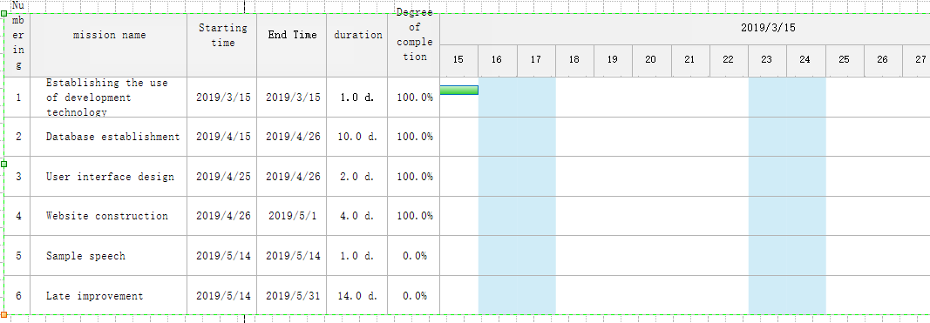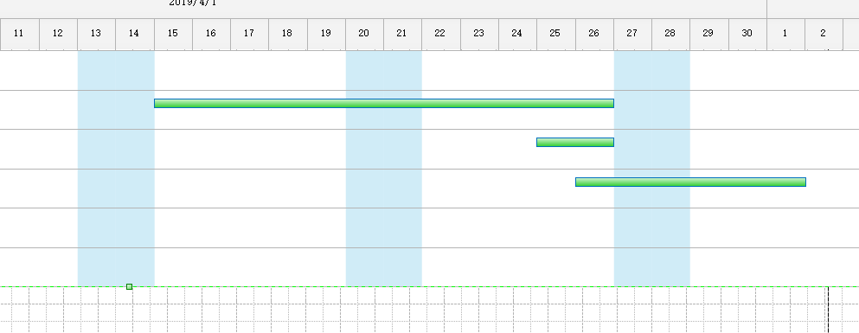In the early stage, our development focus was on the website, but with the continuous development of mobile devices, our users may have demand for mobile phones. We will continue to investigate user needs and make new improvements according to market needs. Once our website is built, we may test it, correct the problems we find, and discover some of the features that we have found that we don't have, and add new features.

For our current shopping software, we will do a lot of work in the future to improve and optimize the software to provide better service to users. Large item information is a prerequisite for ensuring traffic to the shopping platform, so it is important to expand the user base. Vigorously promote our item trading platform to allow more people to register and publish items. We can push the item information according to the user's past shopping, let the user feel the intimate service, remind the user to have their favorite items on the shelves. In order to maintain a large flow of the platform, we must ensure that the user's shopping is comfortable. So we have some feedback on the problems caused by the software for some customers shopping, and timely improvement

|  |  |  |
| --- | --- | --- |
| Group member name | student ID | Complete project |
| William | 66195207 | System Requirements |
| Chandler | 66088445 | User Interface Specification |
| Palmer | 23137342 | Plan of Work |
| Caden | 84751102 | Customer Problem Statement |
| Guy | 84651951 |  |
| Jay | 49038231 | Functional Requirements Specification |